1. Getting started with React Application

Below are the some react commands In the project directory, you can run:

npx create-react-app my-app

cd my-app

Creates new react application against the current directory.

npm install / npm install packagename

Will install all prerequisite pacakges for react application

npm start

Runs the app in the development mode.\ Open http://localhost:3000 to view it in your browser.

The page will reload when you make changes.\ You may also see any lint errors in the console.

npm test

Launches the test runner in the interactive watch mode.\ See the section about running tests for more information.

npm run build

Builds the app for production to the build folder.\ It correctly bundles React in production mode and optimizes the build for the best performance.

The build is minified and the filenames include the hashes.\ Your app is ready to be deployed!

See the section about deployment for more information.

npm run eject

Note: this is a one-way operation. Once you eject, you can't go back!

If you aren't satisfied with the build tool and configuration choices, you can eject at any time. This command will remove the single build dependency from your project.

1. Deploy code on AWS S3 as static site using AWS Code PipeLine

First need to create repository in AWS Code Commit service.

Steps :

1. Login to aws console using IAM/Root user login, and select code commit service.

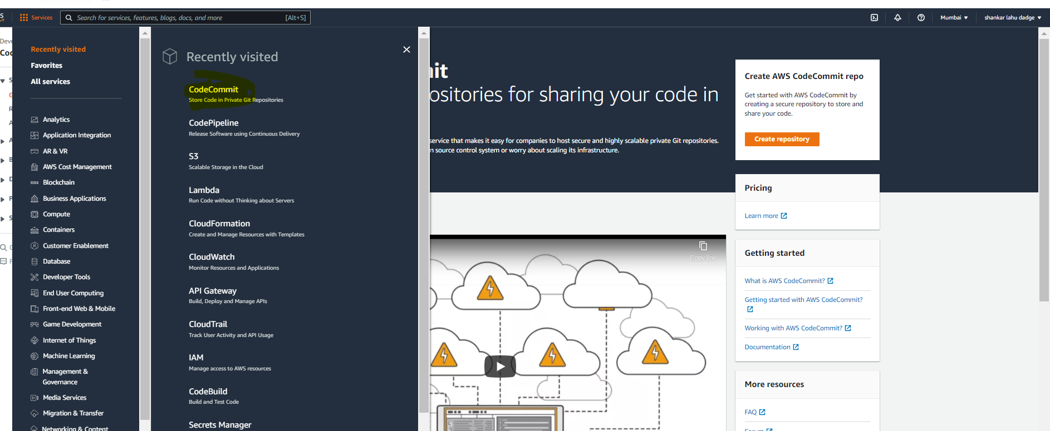

1. Need to select Create Repository option here

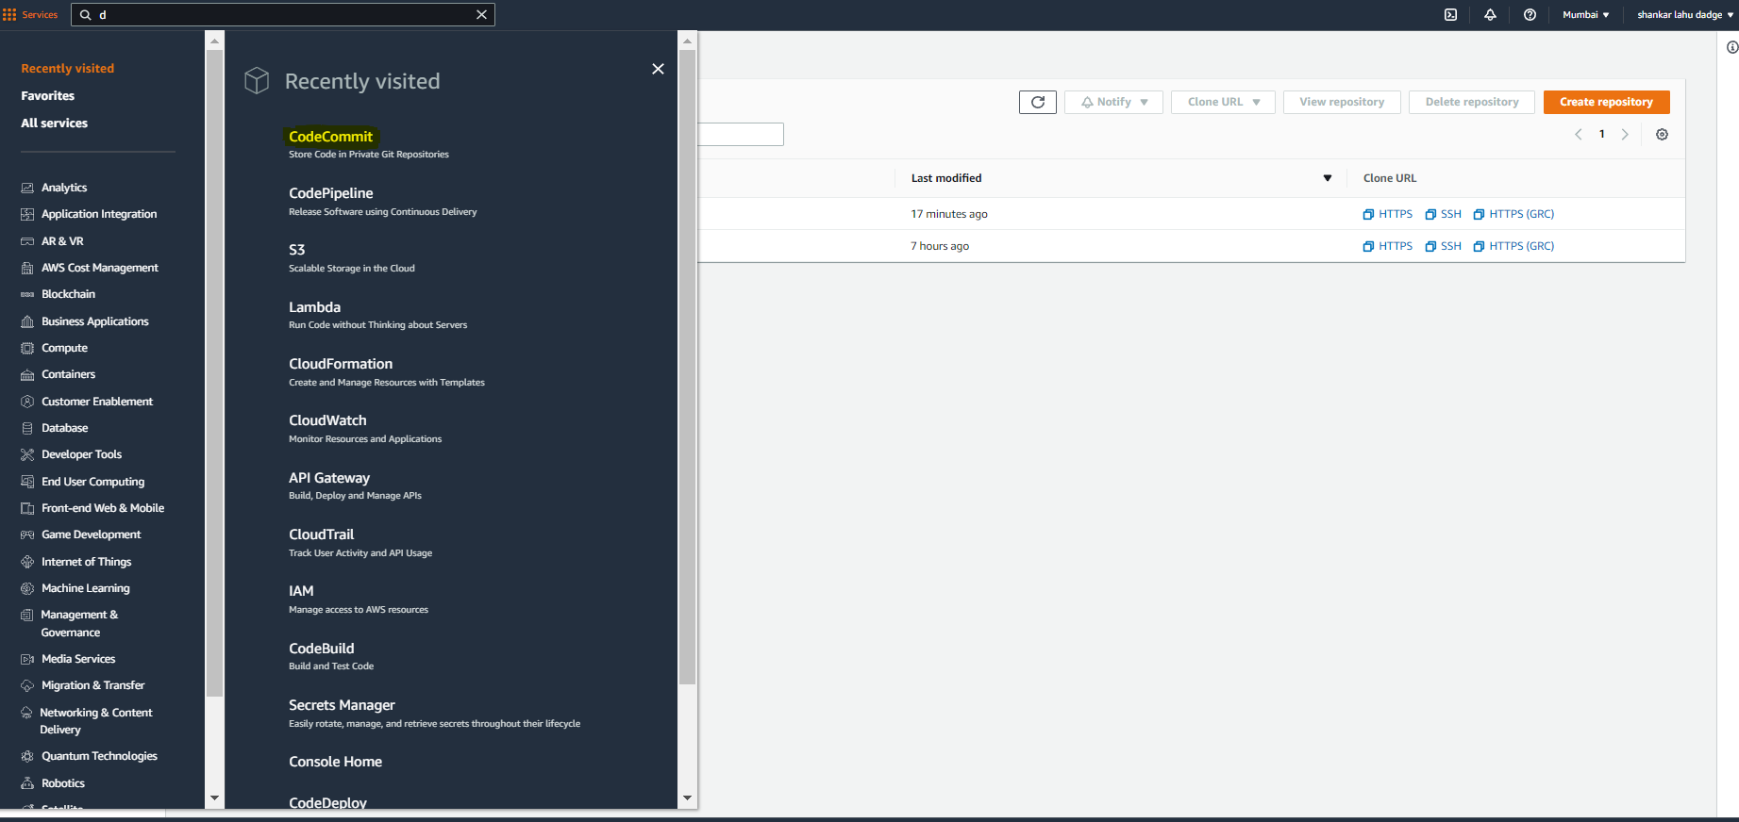

1. On click of create repository option, it will open create window. Here we can fill Repository name for our react app and othe info is optional.

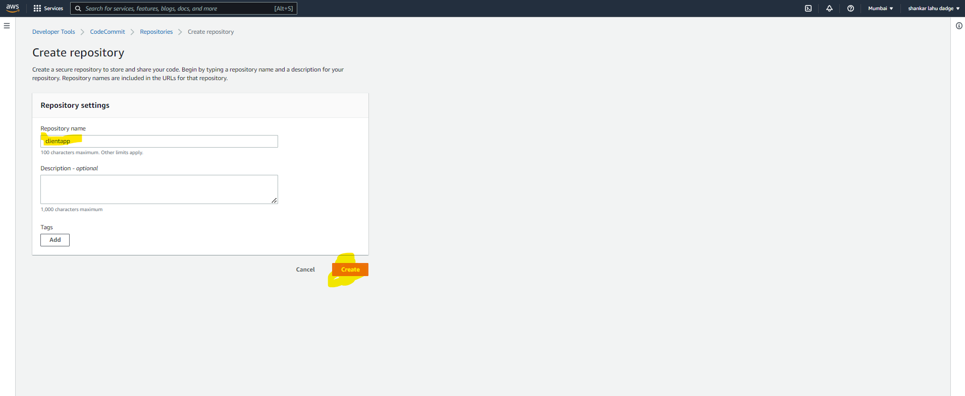

1. It will create source repository on AWS Code Commit

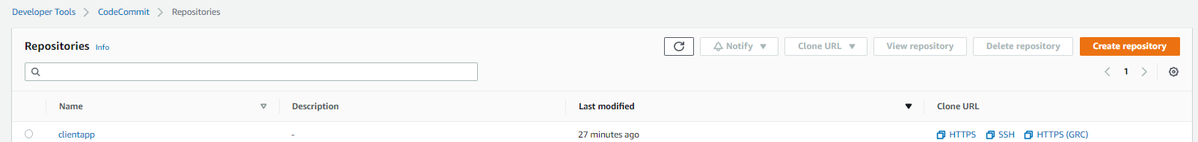

1. We can clone the repository in our local machine using Clone URL and CodeCommit User Credentials.

By clicking on https clone option against the repo we can copy the URL

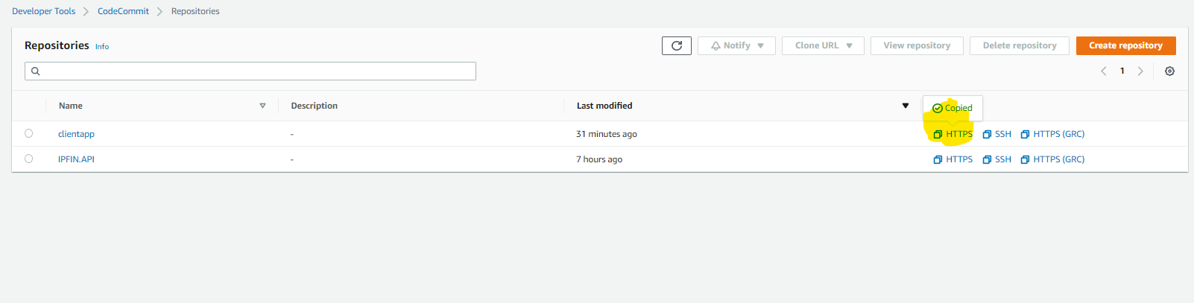

1. Using git on local machine we can clone the repository.

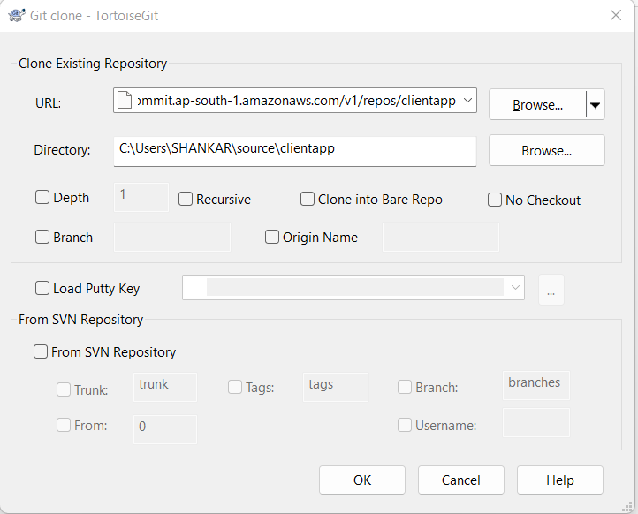

7.Creadentials for Code Commit repo checkout/commit need to create against the IAM user.

i) Open IAM aws service

ii) Select users option

iii) Select IAM user

iv)Select security credentials option

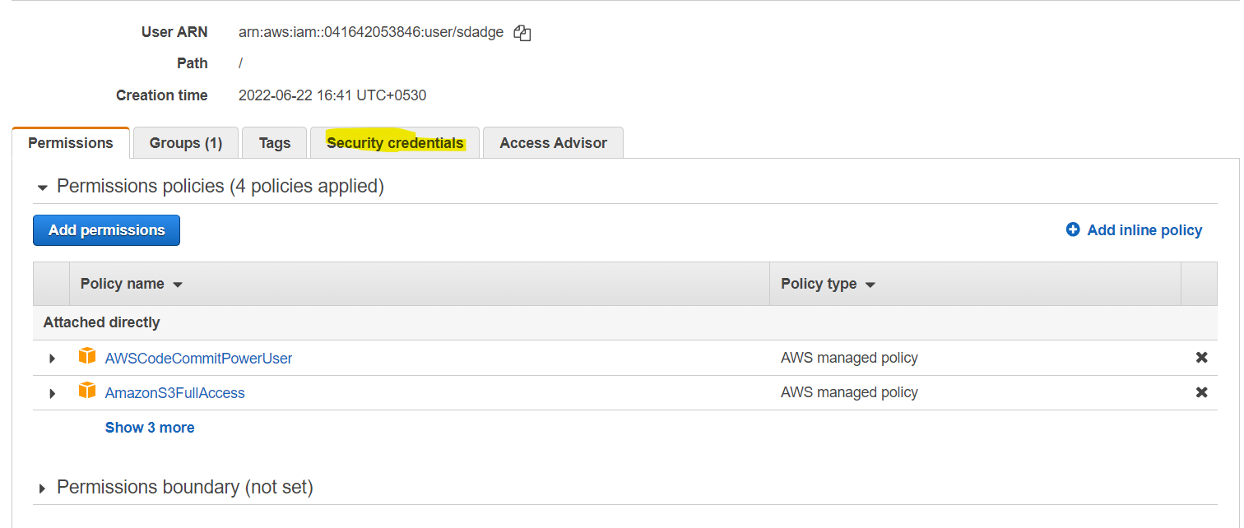

v) Genrate code commit git credentils using Genrate Credentails option

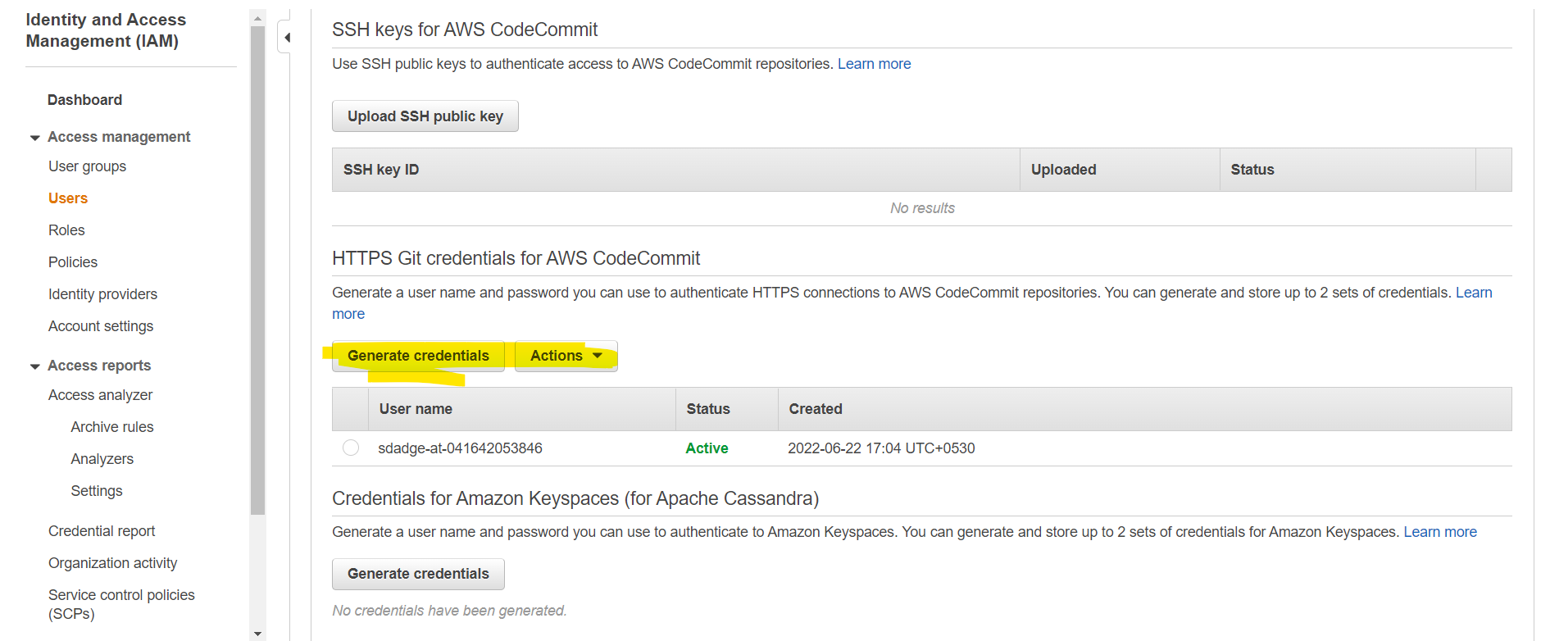

vi) Using thease credentails can be checkout and commit our react application.

8) To build our application on code pipeline and deploy on AWS s3 as static file, need to prepare buildspec.yml and need to commit in root directory of our project.

It will contaons basic prebuild, build and post build commands, artfact, stage and many more conformation.

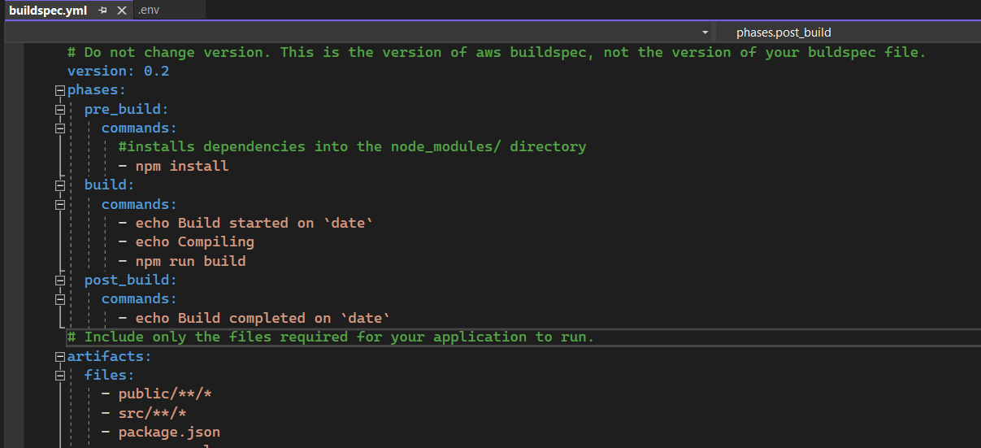

9) Now to deploy application through CICD, we need to create AWS Pipeline

i) Select Pipeline service

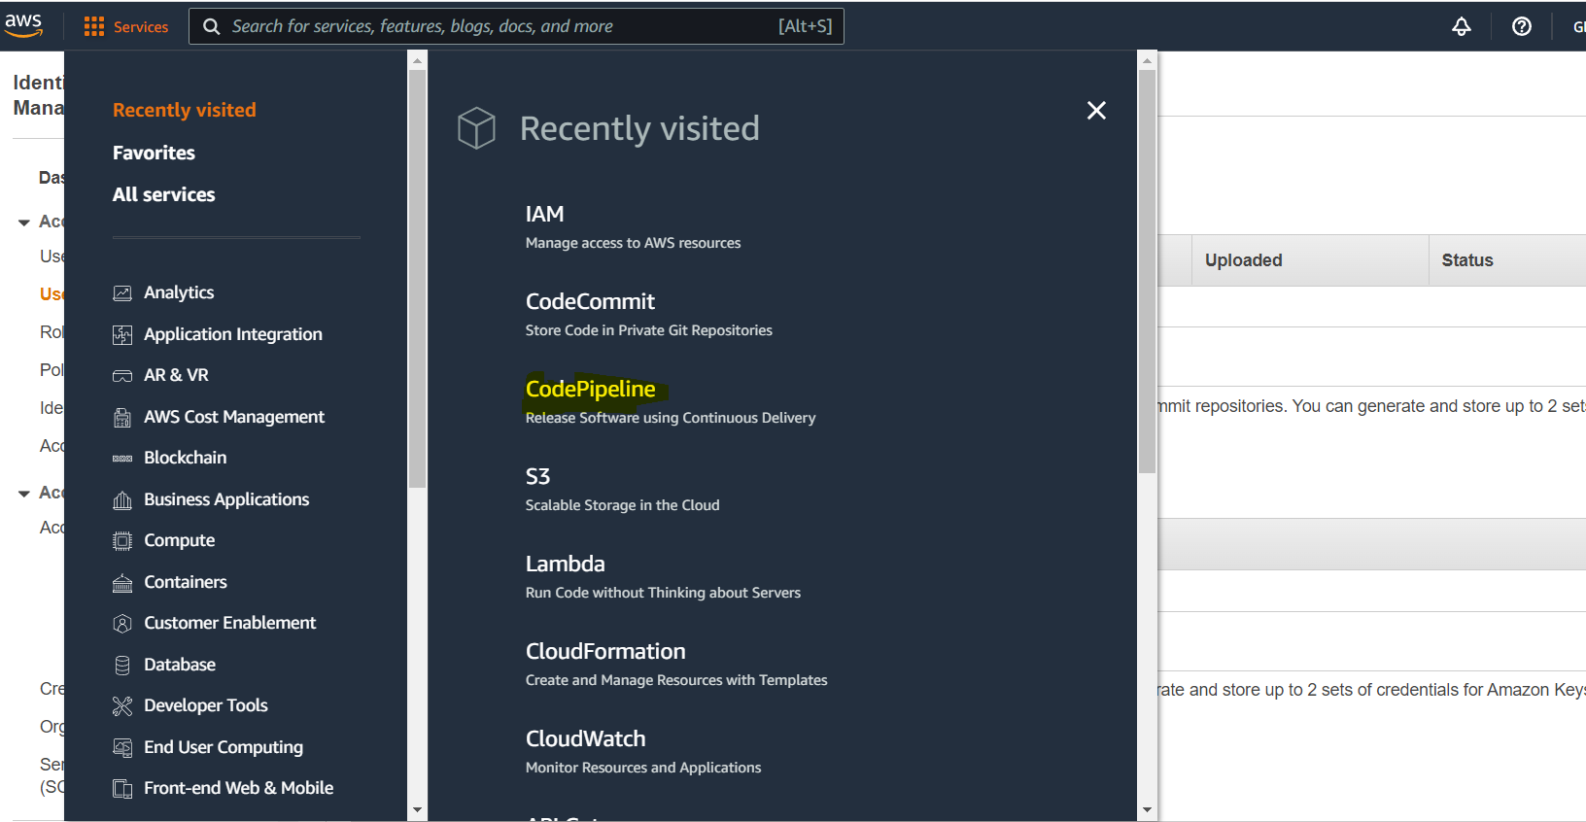

ii) On click of CodePipeline ite will open new window where developer can select Create New Pipeline option.

ii)It will open new window where nedd to fill Pipelinename, and need to select serivce role.

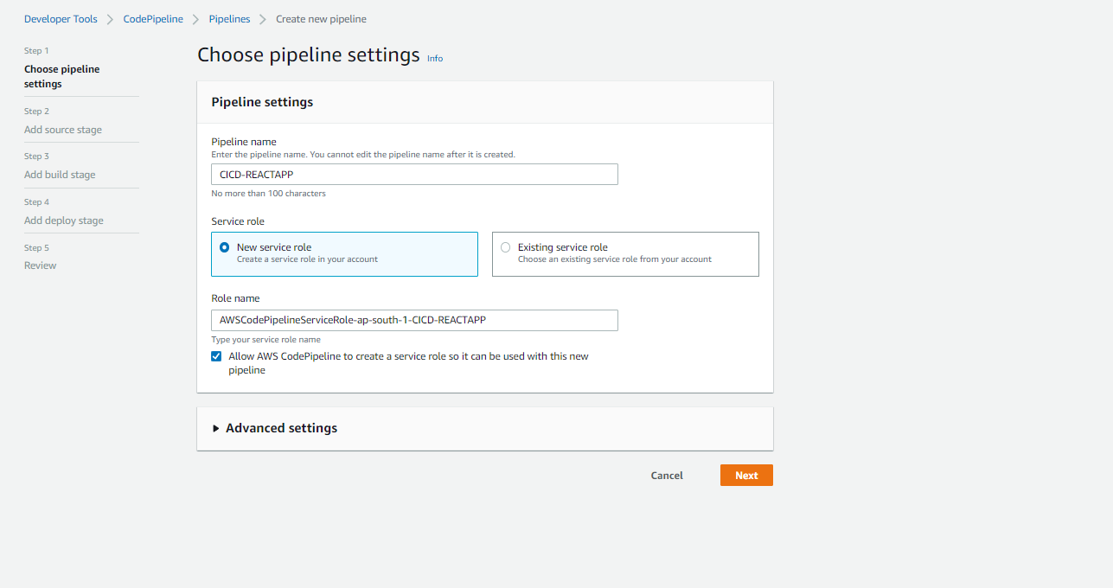

ii) click on next button and Fill source stage information, this will our Code Commit Repo information. Select appropriate repo and branch. Change detection option is pipeline triggering point. If any change commited against the repo it would be trigger pipeline.

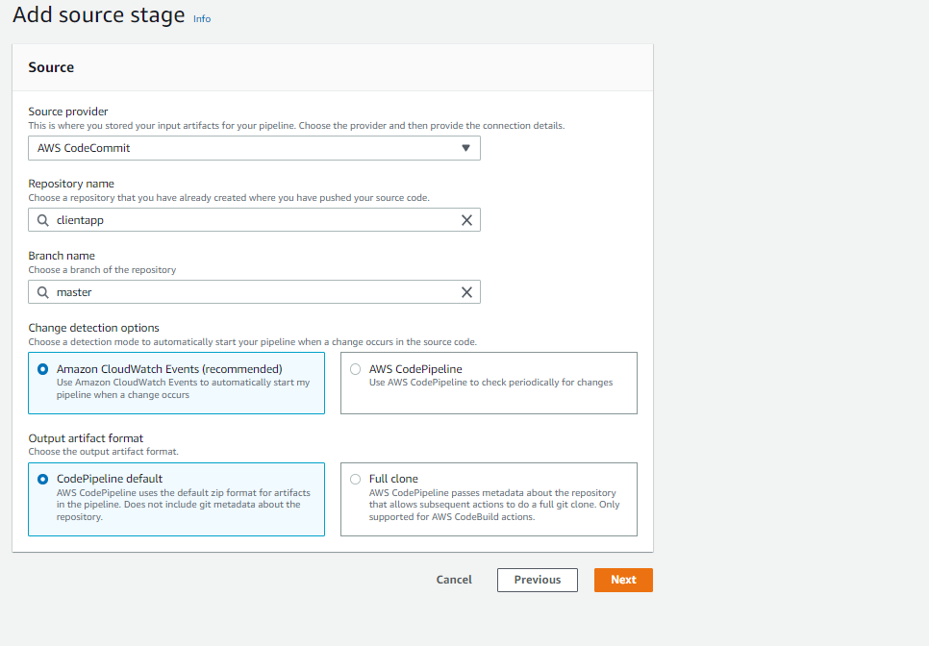

iii) Then we need to fill build stage information.

Here we need to select build proivder, region and project. If project is not there then need to select project option.

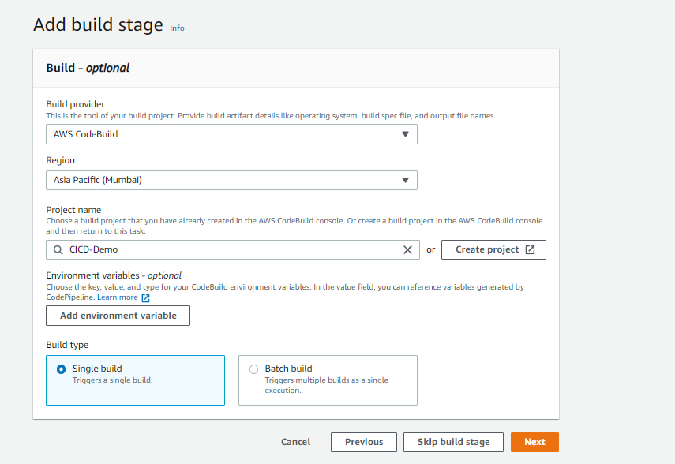

iv) While creating project of build stage, we need to provide project name, operating system, Image information, runtime, build spec and Log source. 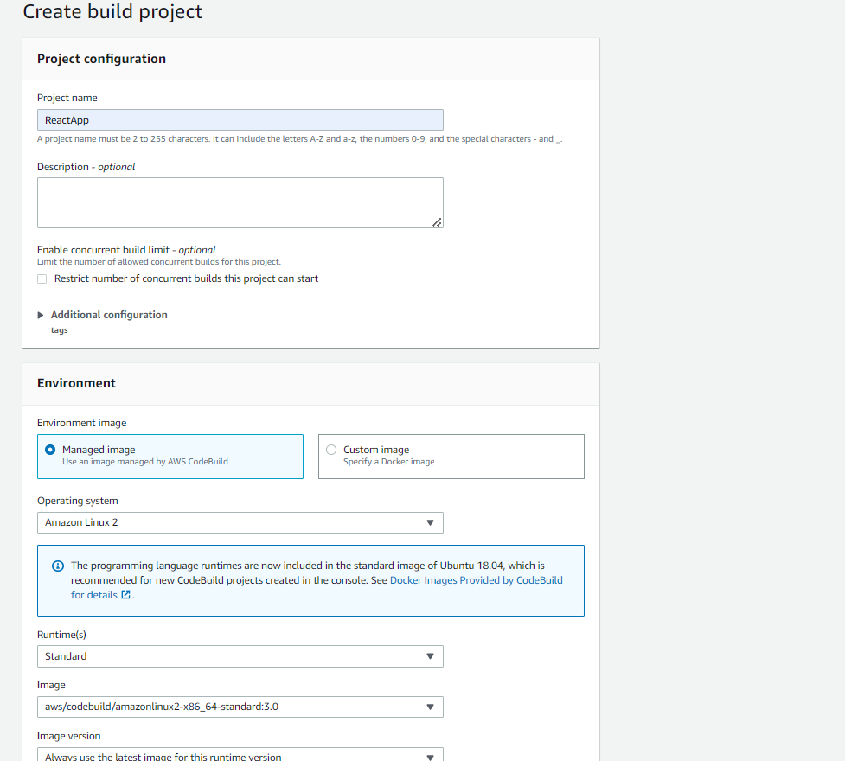

v) we have already Build Spect file in the root directory so select buildspec file option

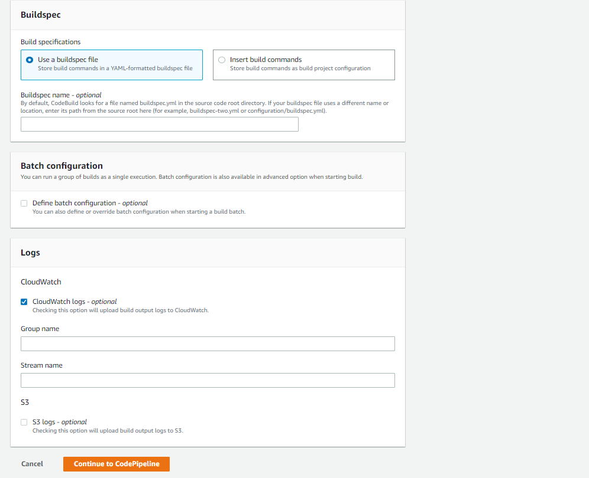

v) Add the deploy stage, which will deploy build on S3 bucket.

Here we need to specify the S3 bucket, Region, Build Artifact information.

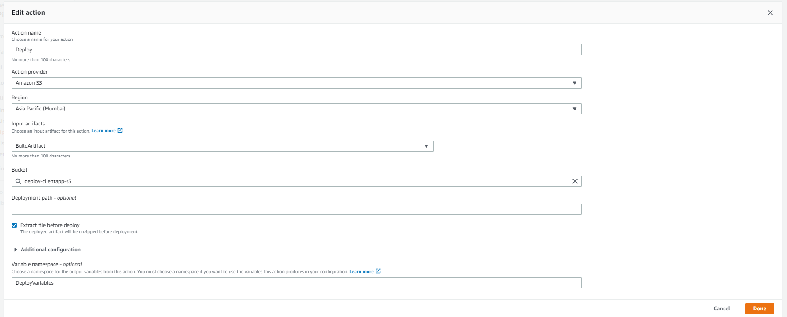

vi) Now our pipeline is ready , It will trigger on code commit or manualy.

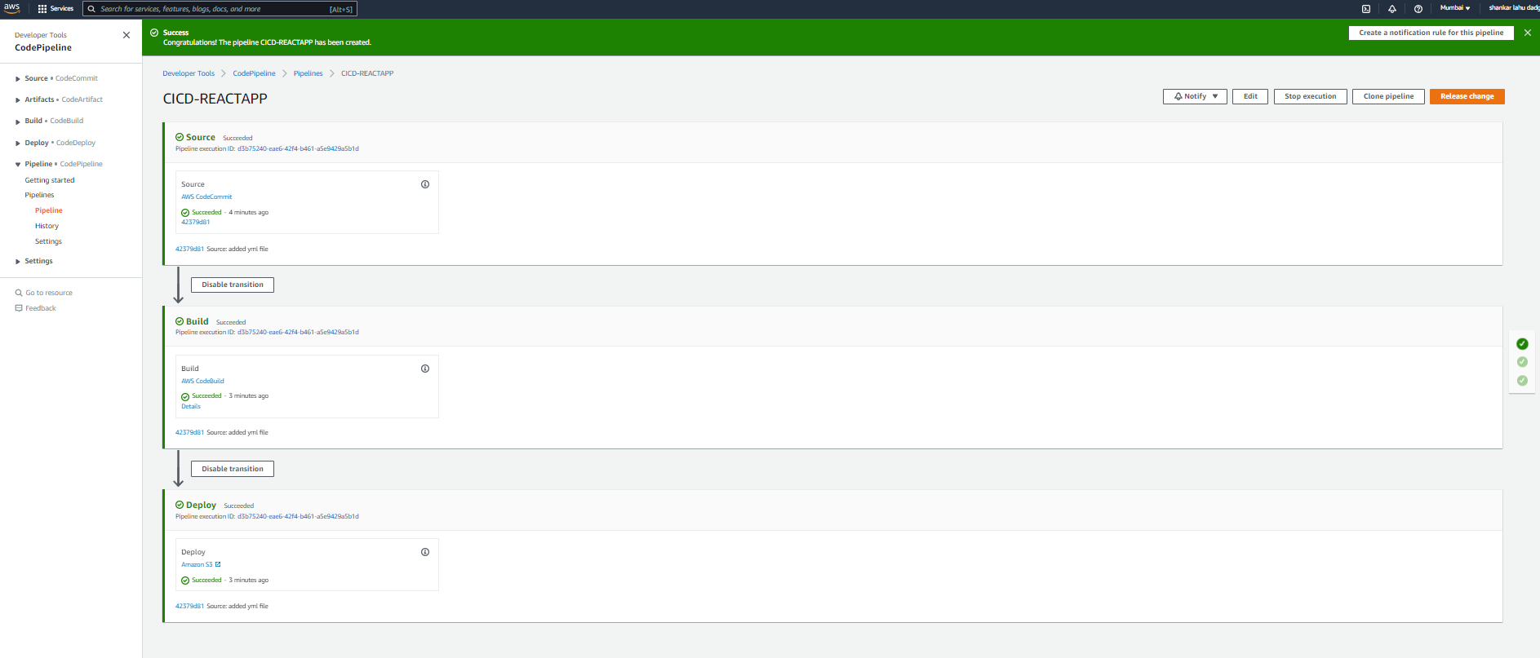

vii) After pipeline succeed for all stags, code will deploy on S3 Bucket.

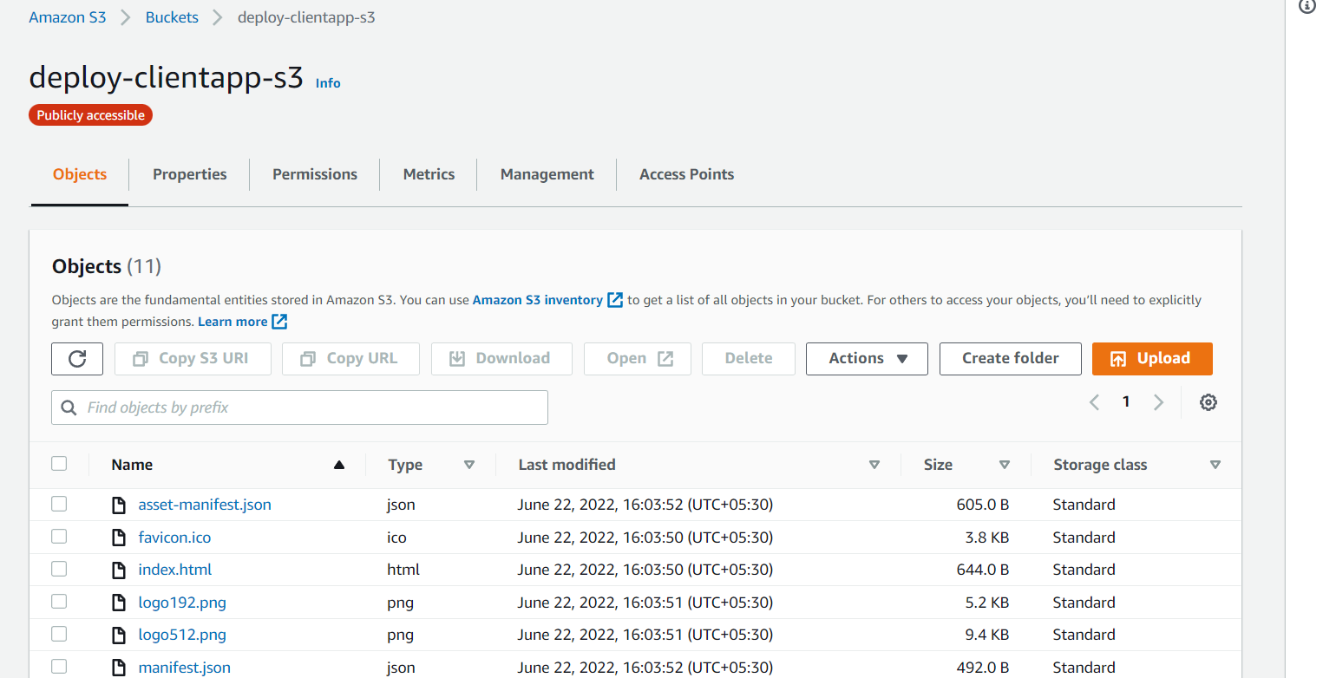

viii) To get URL of react app select property option of S3 and then select Bucket website endpoint.

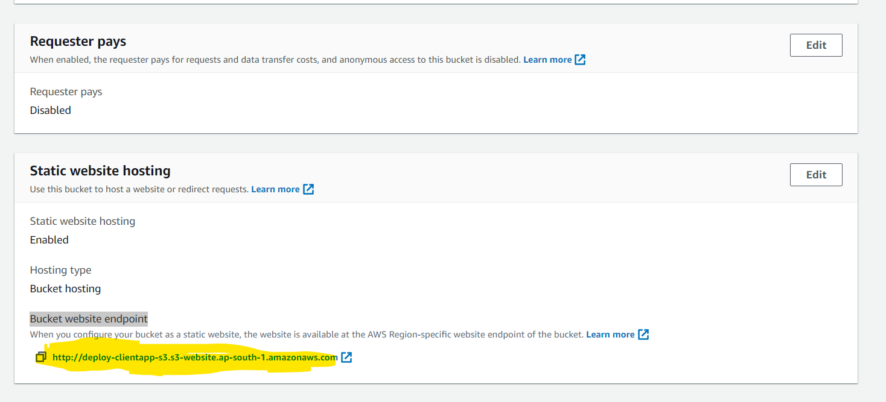

ix) Open URL in browser, it will open our application.

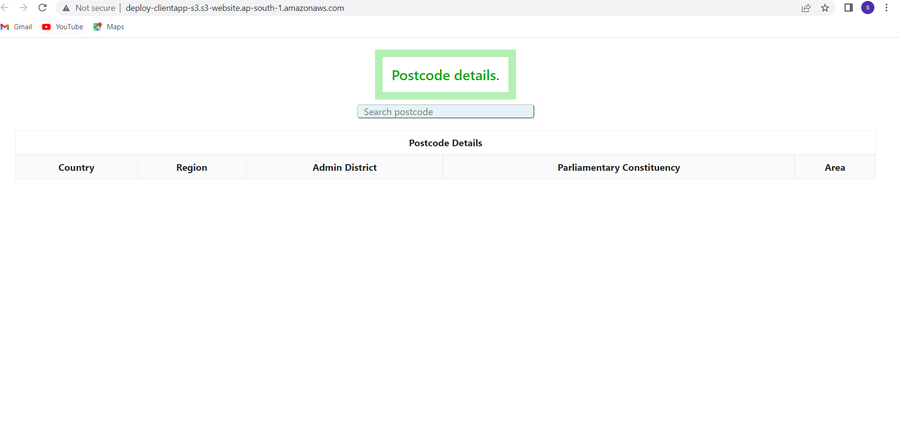

10) Application Guide

i) User can search post code.

ii) on select of post code it will open post code details.

